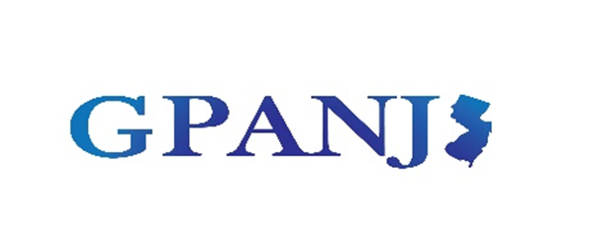
Governmental Purchasing Association of New Jersey, Inc.

2025 Fall Mini-Conference

REGISTRATION IS NOW OPEN FOR THE

GOVERNMENTAL PURCHASING ASSOCIATION OF NEW JERSEY’S

FALL MINI-CONFERENCE

5 CEU CREDITS IN ONE DAY!

(Credits available for QPA, RPPO/RPPS, CMFO/CCFO, RMC, CTC, CPWM)

WHEN: September 25, 2025

WHERE: Windsor Conference Center/Holiday Inn, East Windsor, NJ 08520

CLICK HERE FOR FURTHER INFORMATION AND TO REGISTER

