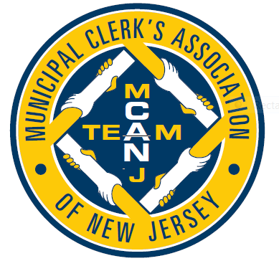

***MCANJ***

***JUNE***

***NEWS***

Dear Members,

June is brain injury awareness month. In March 2019 I fell on the ice and a week later I was diagnosed with a concussion. Treatment: two weeks without any physical or cognitive activity. Just try it. It was one of the most difficult things I have ever had to do. If someone hits their head – be aware of the potential for brain injury. Yes – to this day, my husband still tells me that my brain is scrambled.

The MCANJ Good News for June 2020 is;

#1. Let us welcome Lucy Samuelsen, Municipal Clerk Somers Point City, Atlantic County, as the MCANJ incoming Secretary. The Executive Board shall be conducting their annual transition meeting 19 June 2020 and coordinating the new administration. I anticipate many bylaw changes during FY 2021 to develop cancellation and refund policies.

#2. Have you heard about S-2496? Here is the link <https://www.njleg.state.nj.us/2020/Bills/S2500/2496_I1.PDF>

This bill allows the office of the Municipal Clerk to receive voted mail-in ballots and applications for those ballots by hand delivery; extends deadline for mail-in ballots to be received and canvassed.

My telephone and email have been so busy receiving your comments. Some items of concern are;

* The 10th day before the election is a Saturday. Most municipal offices are not open on weekends.
* A photo ID is required to hand the Municipal Clerk your ballot, but a photo ID is not required to put your ballot into one of the five drop boxes placed throughout each county.
* How is a Municipal Clerk to deal with messenger ballots that arrive with more than 3 ballots?
* What is the delivery schedule for ballots between the Municipal Clerk and County?
* What is the transportation means for this delivery?
* If the Municipal Clerk is summoned into Court, because of the handling of the VBM ballots or challenged, is the County indemnifying the Municipal Clerk?
* What legal protection is being offered to the Municipal Clerk?
* Some municipal offices have had staffing furloughs in response to COVID-19, how are they to take on this additional responsibility?
* Many municipalities do not have municipal police security. Are we to ask the NJSP for additional presence?
* The concept of VBM ballots is to avoid person-to-person exposure. The collection of VBM would open buildings that are closed to the public.
* Additional responsibility would be placed in the Municipal Clerk office to assure trained staff in the collection process is available to receive a VBM ballot
* We understand the need for this as a temporary measure during this pandemic condition, but why is this a permanent bill?

Thank you to the Municipal Clerks who joined me listening to the Senate Budget Committee, Monday 1 June 2020. After a long discussion on the COVID-19 impact to the State budget, the Committee Chair announced that they would not be getting to the two bills and there will be amendments forthcoming for the VBM Ballots and legislation regarding outdoor dining. I have no updated information on a rescheduled date/hour for discussion on S2496. Follow your e-blasts and we will share whatever information comes to our attention.

#3. To the membership of MCANJ – Thank you for the honor of being your FY 2020 President. I am so so very sorry that we were not able to provide you with your annual Education Conference. It was completely taken out of our control. These last five years I have collected ideas and resources to give you the conference I promised, like no other, but I failed you. I have always looked on the annual Education Conference as a rejuvenating event. The networking and the informational exchange has always brought me back to the office with a new sense of energized responsibility. Under the COVID-19 conditions this year we all needed something to stimulate our mental psyche. I look forward to being with many of you at the MCANJ Conference 2021.

Remember to “be the one” to take that first step of making a difference.

We can’t always help everyone, but we can start by helping *someone*.

Be that one today

Here is to celebrating you – the members of MCANJ.

Be safe, be well and be positive. This year is going to go down in the books as a year of complete crap.

But we are Municipal Clerks of New Jersey and we are strong! Thank you everyone.

Diane M Pflugfelder RMC, MMC

Municipal Clerk/Administrator

Township of Liberty

349 Mountain Lake Road

Great Meadows, N.J. 07838

Telephone: 908.637.4579