njmma FALL conference

REGISTRATION FORM

Tuesday, September 14 and Wednesday, September 15, 2021
Ocean Place Resort & Spa, Long Branch, NJ

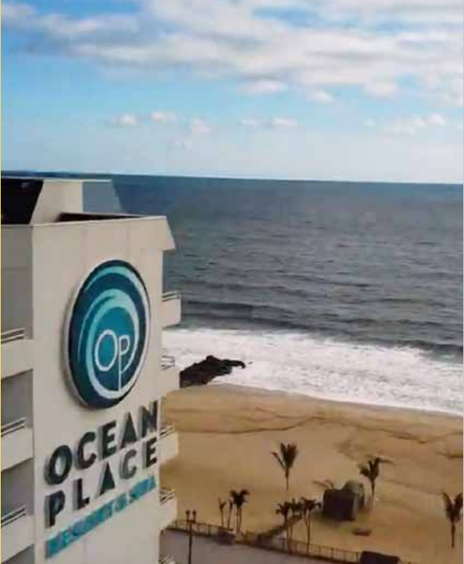

Name:
Position: | Municipality/Company:
Phone:  Email: | Street:  City:  State/Zip:
Please advise number of guests (if any) _____________ (guests will be charged $60 per meal)
Guest/Spouse Names, please: _________________________________; _________________________________; _________________________________

Please return this form with a purchase order/check on or before 8/15/21 to: Thomas Kenny, Executive Associate, NJMMA, Rutgers Lifelong Learning Center, 3 Rutgers Plaza, 3rd Floor, New Brunswick, NJ 08901. You may send purchase orders via fax to (732) 932-3586 or via email to: tek49@docs.rutgers.edu.
A separate registration form is required for every person attending the conference (except guests/spouses – see above)
Registration fee for both days is $300.00 - includes all sessions and meals. Registration for daily attendance is $100.00 on Tuesday and $200.00 on Wednesday.

PLEASE NOTE: Participants will be responsible for reserving their own sleeping rooms. Room rates are $279.00/night plus any applicable taxes and charges (please use the following link to book your room
BOOKING LINK: https://reservations.travelclick.com/13199?groupID=3226899).

Thank you!

